**How Much Does it Cost to Outsource School Website Design?**

In the modern digital landscape, having a website is a fundamental aspect of any organization's branding and marketing efforts. Educational institutions, including schools, are not exempt from this reality. A professionally designed website enables schools to effectively showcase their facilities, core values, and notable achievements, while simultaneously providing user-friendly access to crucial information for parents, students, and staff members.

This comprehensive article will delve into the expenses related to outsourcing school website design projects, examine the factors that influence these costs, and discuss the advantages of opting for outsourcing over maintaining an in-house design team.

At the end of this article, you will possess a deeper understanding of the website development costs and the reasons why outsourcing could be the most suitable choice for your school's website requirements.

## **Why Should You Outsource School Website Design?**

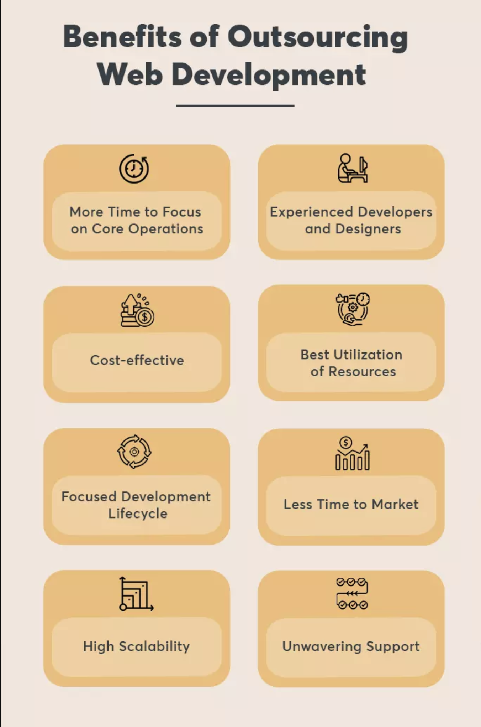

[Source](https://thegraybear.com/wp-content/uploads/2022/03/benefits-of-outsourcing-web-development.webp)

There are several reasons why schools should consider outsourcing their website design:

### **Access to Technical Expertise**

Outsourcing allows schools to tap into the knowledge and experience of professional web designers. These companies have skilled designers, web developers, software developers, search engine optimization analysts, and project managers who have worked on countless projects, ensuring your school website is built to the highest standards.

### **Cost Savings**

Outsourcing website development can be more cost-effective than hiring and maintaining an in-house design team which comes with a very high price. You don't have to worry about the ongoing costs of salaries, benefits, training, and office space as you are only hiring freelance web designers who have their own offices.

### **Time Savings**

By outsourcing, schools can focus on their core responsibilities—educating students—while letting the experts handle the design and development of their websites.

### **Scalability and Flexibility**

Outsourcing provides schools with the flexibility to scale up or down their website requirements as needed. They can opt for the development of your school's own website with cloud hosting, if you have an existing one, you can opt for a complete redesign, regular updates, or website maintenance as required.

## **What Impacts the Cost of Outsourcing School Website Design?**

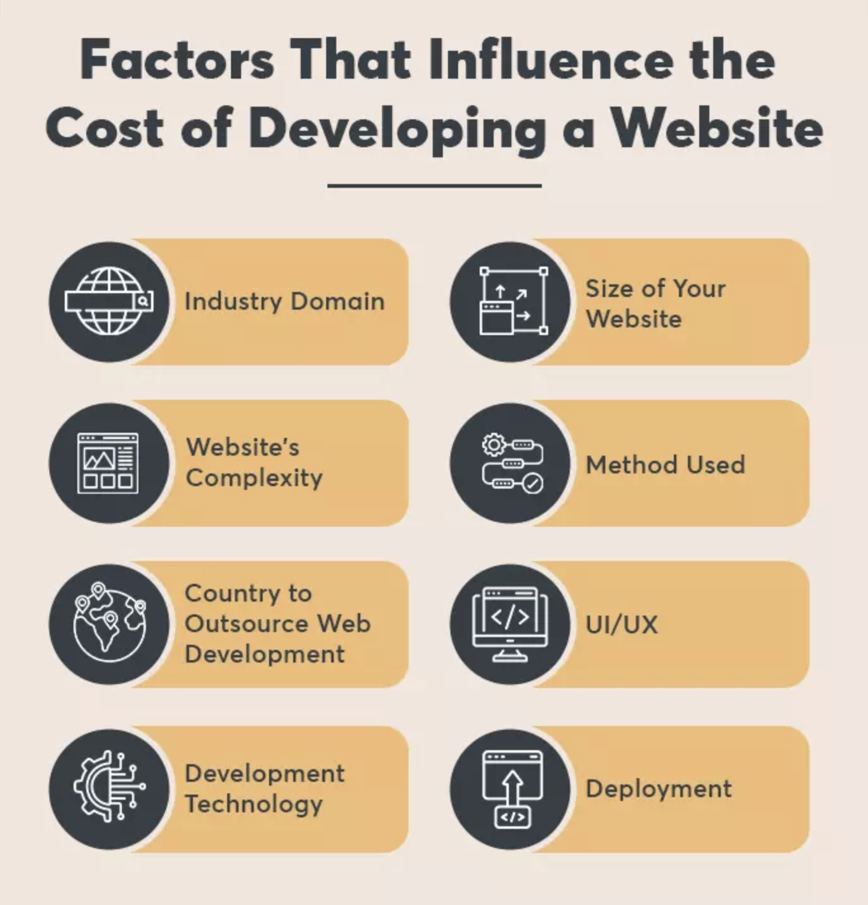

[Source](https://thegraybear.com/wp-content/uploads/2022/03/how-much-does-outsourcing-web-development-cost.webp)

There are several factors that can impact the final website development costs of outsourcing this project:

### **Scope of Work**

The complexity and size of the project will significantly impact the website creation cost. A basic website with a few pages or a one-page site and simple functionality will be less expensive than more complex projects for your website with custom features, integrations like optimization for search engines, databases that requires backend development, multimedia content such as content creation, email marketing for your target audience, and more. You can also take into consideration the web hosting plan costs and other development processes.

### **Design Quality**

The level of design sophistication and customization will also affect the website development price, especially if you build a custom website for your school. Premium designs with high-quality visuals and a unique layout will come at a higher cost compared to those simple website designs.

Sometimes, purchasing a pre-templated design from a website builder can be one of the factors too.

### **Location**

The location of the web design agency or the freelance website designer that you will hire can impact the overall cost. Agencies in countries with lower labor costs can often offer more competitive pricing, while those in high-cost regions may charge more.

### **Level of Support and Maintenance**

Ongoing support and maintenance costs will vary depending on the level of service required. A basic support package may only cover essential updates and bug fixes, while a comprehensive package could include content updates, design changes, and feature enhancements.

## **What are the Average Costs of Outsourcing School Website Design?**

It is essential to note that the costs for outsourcing school website design can vary widely, similar to a corporate website and professional website, depending on the factors mentioned above. However, here are some average cost ranges to provide a general idea:

### **Basic School Website Design**

A basic school website development with limited features and a simple one-page layout may between [$5,000 and $10,000](https://www.freshbooks.com/hub/estimates/how-much-do-web-designers-charge), with $6,760 being the [average cost](https://www.freshbooks.com/glossary/tax/average-cost-method) to set up, design, build, and the whole creation cost.

If your school is new or a small business, there is a free version of website builder such as WordPress Website.

Should you choose to hire freelance web designers, for your custom website, they may charge more or less than [$75](https://www.freshbooks.com/hub/estimates/how-much-do-web-designers-charge) per hour

### **Mid-range School Website Design**

A more sophisticated website with custom features such as website content, integrations, and advanced functionality can range from $8,000 to $15,000 and sometimes, a multiple web designer oversees the project management.

### **Premium Complex Website Design**

Such websites with cutting-edge design, extensive features, and interactive elements can cost [**$40,000 to $75,000.**](https://www.impactplus.com/blog/how-much-does-a-website-redesign-cost)This web creation cost includes the following:

* Web Developer Fee
* Content Management System
* Web Development cost
* Custom landing pages
* Create content

## **Direct Comparison Between Outsourcing School Website Design vs. In-House School Website Design Team**

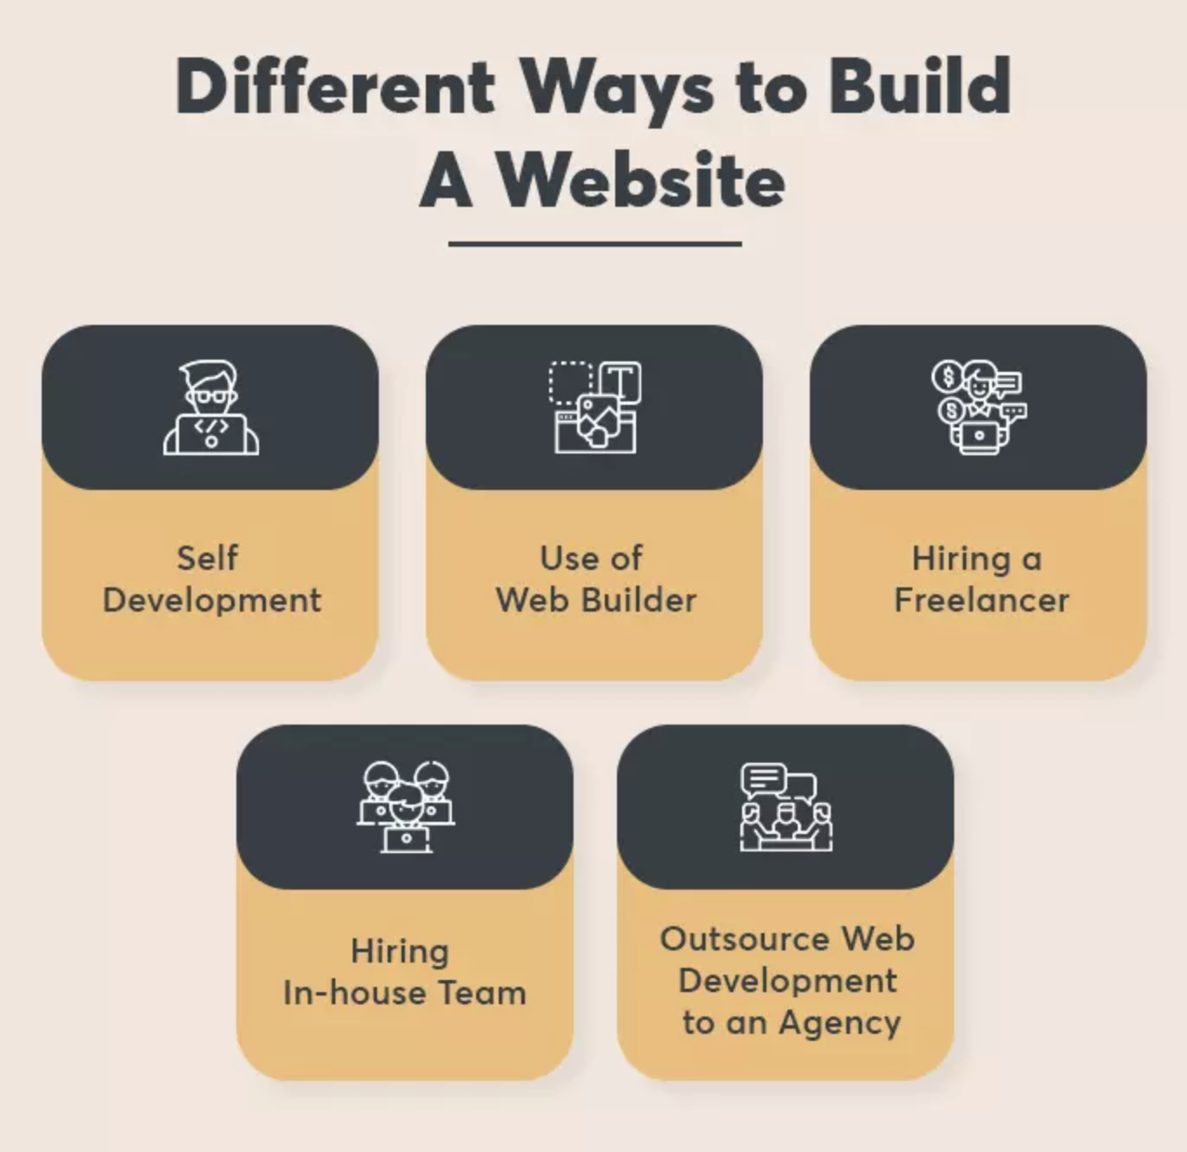

[Source](https://thegraybear.com/wp-content/uploads/2022/03/different-ways-to-build-a-website.webp)

### **Initial Setup Costs**

#### **Outsourcing School Website Design**

The initial setup costs for outsourcing a school website design include hiring a web design agency, which generally charges a flat fee for the project. Depending on the complexity and customization level, the cost can range from $3,000 to $30,000 or more. The advantage of outsourcing is that it usually requires less upfront investment than building an in-house development team.

#### **Building an In-House Web Development Team**

The initial setup costs for building an in-house development team include hiring staff, investing in necessary hardware and software, and providing training if needed. Hiring a team of experienced web developers, designers, and project managers can be costly, with salaries often ranging from $50,000 to $100,000 or more per employee per year. The cost of hardware, software, and training will also add to the initial investment. However, building an in-house team provides more control over the development process and allows for easier long-term maintenance and updates.

### **Ongoing Expenses**

#### **Outsourcing School Website Design**

Outsourcing your school website design typically involves a one-time payment for the project, although some agencies may offer ongoing maintenance and support for an additional fee. These fees can be charged on a monthly or annual basis and can range from a few hundred to a few thousand dollars, depending on the level of service required.

#### **Building an In-house Development Team**

With an in-house development team, ongoing expenses include employee salaries, benefits, office space, equipment, and software licensing. Additionally, there may be costs associated with ongoing training and professional development. While these ongoing expenses can be significantly higher than outsourcing, having an in-house team allows for more flexibility in making updates and maintaining the website over time.

### **Total Cost of Ownership**

#### **Outsourcing School Website Design**

The total cost of ownership for outsourcing a school website design includes the initial project fee, as well as any ongoing maintenance and support fees. If the school chooses not to engage in ongoing maintenance services, the total cost of ownership will be lower. However, schools should be prepared to allocate resources to manage website updates and maintenance in-house, which may lead to additional expenses over time.

#### **Building an In-house Development Team**

The total cost of ownership for building an in-house development team includes the initial setup costs, ongoing expenses, and any additional costs related to training, equipment, or software updates. While this option can be more expensive in the short term, the long-term benefits of having an in-house team may outweigh the costs, especially if the school plans to make frequent updates, add new features, or expand its digital presence.

In comparison, outsourcing your school website design allows you to access professional expertise, save time, and control costs more effectively. You'll only pay for the specific services you require, and you won't need to worry about the ongoing expenses associated with an in-house team.

## **Choosing the Right School Website Developer Provider**

On this note, we recommend working with an experienced outsourcing partner like [The New Workforce](https://thenewworkforce.com/). The New Workforce offers a refined selection of BPOs including website development, sales, IT, customer service, and more. Each employee is selected for their skill and dedication to their trade.

When choosing the right school website developer provider, clients should consider the following factors to ensure they select the best fit for their specific needs:

### **Experience and Expertise**

Look for a provider with a proven track record of designing and custom website development. Their experience in the education sector will ensure they understand the unique requirements, features, and functionalities needed for a successful school website.

### **Portfolio and Case Studies**

Review the provider's portfolio to assess the quality of their work and to see if their design style aligns with your vision. Case studies can offer valuable insights into their approach to problem-solving, project management, and client collaboration.

### **Technical Capabilities**

The developer should have a strong command of current web technologies and platforms, as well as the ability to implement custom features, integrations, and content management systems tailored to your school's needs.

### **Responsiveness and Communication**

Choose a provider that prioritizes open communication and is responsive to your queries and feedback. A strong working relationship will ensure a smoother project process and a better end result.

### **Reputation and Client Testimonials**

Investigate the developer's reputation through online reviews, client testimonials, and industry recognition. Satisfied clients and positive feedback are strong indicators of a reliable and professional provider.

### **Budget and Pricing**

Evaluate the developer's pricing structure and compare it with your budget. While cost is an important factor, avoid compromising on quality for the sake of saving money. Remember that a well-designed website is an investment that will benefit your school in the long run.

### **Ongoing Support and Maintenance**

A good website developer will offer ongoing support and maintenance services to keep your website up-to-date, secure, and functioning optimally. Ensure that the provider you choose offers a support plan that meets your school's needs.

### **Timelines and Project Management**

Determine whether the provider can work within your desired timeframe and has a solid web development process in place to ensure deadlines are met and the project stays on track.

By carefully considering these factors, clients can make an informed decision when selecting the right school website developer provider, ultimately leading to a successful and effective online presence for their institution.

## **All in All**

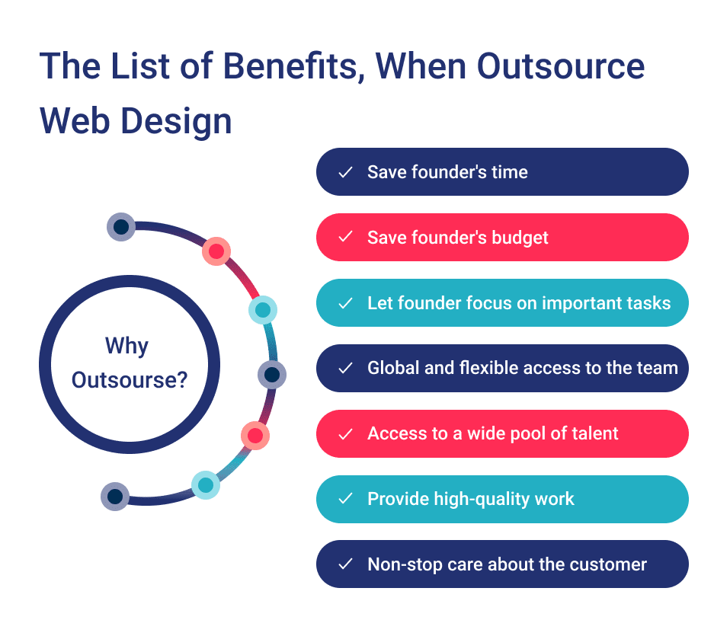

[Source](https://cdn-ckhkd.nitrocdn.com/TBDCGQbQxqGdTdlLdTFaoAGZazJemBHC/assets/images/optimized/rev-b9b15e6/wp-content/uploads/2021/03/picture1-5.png)

Outsourcing school website design can be a cost-effective and efficient solution for educational institutions. By leveraging the expertise of professional web design agencies, schools can create a high-quality, functional, and engaging online presence without the added burden of hiring, training, and managing an in-house team.

The website cost can vary depending on factors such as the project's scope, design quality, and location of the agency. However, considering the potential cost savings, time savings, and access to specialized skills, it is clear that outsourcing is a smart investment for many schools.

When evaluating your options, it's essential to consider the specific needs of your institution, the resources available, and the long-term goals of your online presence. By carefully weighing the pros and cons of outsourcing versus in-house design, you can make an informed decision that best supports your school's mission and helps you achieve your desired outcomes.